**Sign-up for AAUW Two Minute Activist**.   
#AAUWTwoMinuteActivist #AdvocateForYourRight[s](https://www.facebook.com/hashtag/advocateforyourrights?__eep__=6&__cft__%5B0%5D=AZXUvEygNt75_N7SqWUDMhrHI_WlD22zuh06WlOXXmlZM6oO9DxgPPM1_csFL_u09-9Tu4EsKPskadBYewemkm5Ow3oHzMG6Yih3un-rTpP62W9wmQnx3H6OradtU7hKEeuaYYf_VEliimT_AxNIo-EWaR6gMS47-5iwse_WePcziQQ6t8P4VymLRKwwi6G-ta4&__tn__=*NK-R)

#GenderEquityAdvocacy 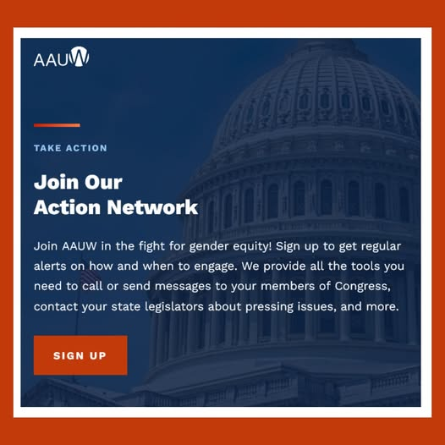

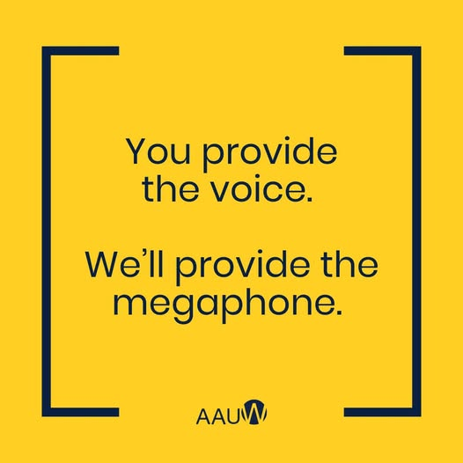

Take action:<https://bit.ly/3kYkfi3> goes to <https://www.aauw.org/act/two-minute-activist/>

