9 Dream Reads Bookworm Barbie Needs in Her Library

By Christian Coleman

Come on, Barbie! Let’s go party . . . in your library! You’re about to become Bookworm Barbie and read the days and nights away. Don’t worry about Ken. He’ll be fine because he’s just Ken. Now that you’re in your self-discovery era, you’ll have lots of questions. Like why you’re in a blockbuster summer movie and how the film industry works. We got you. And everything you want to know about empowerment for women and girls, beauty (and health) standards, life in plastic in the real world, the patriarchy, and all the badassery in women’s history is in these books from our catalog. Each sold separately!

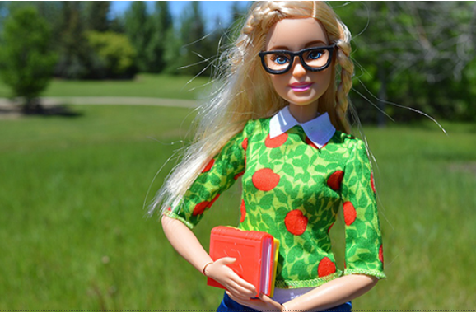
All Made Up: The Power and Pitfalls of Beauty Culture, from Cleopatra to Kim Kardashian
To talk about makeup is to talk about power: who has it, who wants it, and who is trying to keep it . . . Trying to understand people’s use of makeup throughout history and the influence it has had on culture and social structures is a way to reflect on people’s humanity. People of all genders wear makeup because they are getting something out of it, and the benefit is worth the time, effort, and money they spend. Learning about why people wear makeup sheds light on how people live and how the world is constructed.
—Rae Nudson

American Plastic: Boob Jobs, Credit Cards, and Our Quest for Perfection
World War II left a longing for large breasts in its wake, a longing that fed a growing practice in breast augmentation. Why Americans suddenly became obsessed with large breasts is an interesting question . . . Surely 1950s anxiety over producing a “normal” girl, which increasingly fed into young girls’ desires for large breasts, shaped this obsession with “the sweater girl.” The year 1959 proved to be a watershed year for cosmetic surgery, since that was when Barbie was introduced to the American toy market and an entire generation of young girls grew up worshiping a form impossible to achieve without surgical intervention.
—Laurie Essig

Here She Is: The Complicated Reign of the Beauty Pageant in America
Fittingly the Barbie doll was born at the end of the 1950s, and it was seen by many as the symbol of female oppression. With her unrealistic figure she has endured many of the complaints about women’s body image issues. Barbie-like physical expectations found real world expression in events like debutante balls, sorority rush, prom preparation, cheerleading tryouts, and stewardess application restrictions. None of these events are pageants, but they are undoubtedly pageant adjacent, as women are evaluated and selected for activities based in large part on how they look. In most of these realms, the primary goal for women was matrimony, but women also wanted to be seen, and heard, in public.
—Hilary Levey Friedman

The Patriarchs: The Origins of Inequality
If patriarchal ways of organizing society happen to look eerily similar at opposite ends of the globe now, this isn’t because societies magically (or biologically) landed on them at the same time, or because women everywhere rolled over and accepted subordination. It’s because power is inventive. Gendered oppression was cooked up and refined not only within societies; it was also deliberately exported to others for centuries, through proselytism and colonialism.
—Angela Saini

The Seven Necessary Sins for Women and Girls
If we are to save girls, wherever they live in the world, if we are to nurture the pilot light of anger that guides them to their true north, feminism must be as universal and commonplace as patriarchy. But it must be a feminism that terrifies patriarchy, a feminism fueled by rage as foundational to its strength. Anger is that bridge that carries feminism from idea to being, from the thought “How the fuck is this happening?” to “This must fucking stop.”
—Mona Eltahawy

What We Don’t Talk About When We Talk About Fat
Thinness takes so much from fat people too . . . It takes away our ability to describe our own bodies, replacing our own descriptions with something thin people can understand—something that makes them feel comfortable, less threatened, and less privileged. And when it takes away our descriptions of our own bodies, it also takes away our ability to describe our own experiences and know that they’ll be heard on their own terms. It takes away quiet, everyday activities too: eating, working out, buying groceries, and shopping for clothes all become seen as unspoken invitations to comment on our bodies, our practices, the weight loss in which we must be in hot pursuit.
—Aubrey Gordon

Women and Other Monsters: Building a New Mythology
I’ve had a long-standing interest in female heroes, the women who have broken through gendered notions of who is allowed to embody valor and strength, and I was beginning to suspect that monsters, perhaps ironically, could offer a whole new approach to heroism for people (like me) who are often tripped up by feminine ideals. The qualities we hail as heroic in Western culture—courage and fortitude, selflessness and nobility, steadiness of mind and will—are not unique to men. Arguably, they’re not even characteristic. But in the male-dominated myth, folklore, and literature that defines our culture, they’ve been annexed as “masculine” traits. We’re still struggling to create or consume stories about valorous women, unless they also display the “feminine” virtues: passive sex appeal and fragility that requires rescue. In a hero, these are flaws.
—Jess Zimmerman

Women Warriors: An Unexpected History
In the case of women warriors, the tendency to erase women’s roles in history is complicated by the contested question of whether women should fight. Many people who cheer for the highly sexualized women warriors of popular culture are less comfortable when confronted with real-life images of camouflage-wearing women with shaved heads at boot camp or Ranger School. In fact, that contrast gets at the heart of much of the long-standing, cross-cultural social discomfort with women warriors—the fear that women who chose to fight will lose their femininity or, conversely, that their presence will “feminize” the army, thereby rendering it less effective, less aggressive, less serious, or just less.
—Pamela D. Toler

The Wrong Kind of Women: Inside Our Revolution to Dismantle the Gods of Hollywood
In spite of the mountains of data demonstrating that films by and about women (and other non-white, non-cis, non-straight, non-able-bodied men) make more money, Hollywood persists in primarily telling stories about white men. In the few instances when the story is about somebody else, the stories are still being told by cis, straight, able-bodied, white men. Despite their continued near-total stranglehold on content creation, however, some men say they are feeling extremely oppressed just at present.
—Naomi McDougall Jones

About the Author
Christian Coleman is the digital marketing manager at Beacon Press and editor of Beacon Broadside. Before joining Beacon, he worked in writing, copy editing, and marketing positions at Sustainable Silicon Valley and Trikone. He graduated from Boston College and the Clarion Science Fiction & Fantasy Writers’ Workshop. Follow him on Twitter at @coleman_II.

